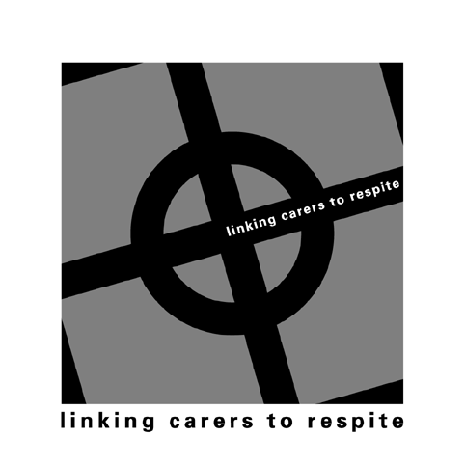
COMPREHENSIVE INFORMATION SHEET

REGISTRATION FORM

Date Carer Details 1800 Yes  No 

Carer’s Name DOB
Address

Phone (02)
Are you a live in carer Yes  No  Relationship to person caring for:
No of people caring for: Verbal consent for referral Yes  No 
Country of Birth Aboriginal Yes  No 
Language spoken at Home Interpreter Yes  No 

Income source
Pension - Full  Part  Nil  Carer Allowance Recipient 
Carer Payment  Employed - Part-time  Fulltime  Other 
Pension – DVA  Number___________________ Gold  White 

Length of time as a carer

Less than 1yr  3 – 5yrs  5 – 10yrs  More than 10yrs 
Date commenced:
Caring Role
Carer’s Health (physical and emotional impacts on caring role)

What are your other responsibilities (work/domestic/family/relationship)

Carer’s Goals: (for themselves and person they care for)

What effect is your caring role having on you and your family (capacity to continue)

What support do you get from family/friends

What would assist you in your caring role

What is the state of the relationship with the person for whom you care

Current pattern of responsibilities and time commitments

What are the sleep impacts in your caring role

What is the financial impact of your caring role

Social impacts of caring role

What are your information and education needs

