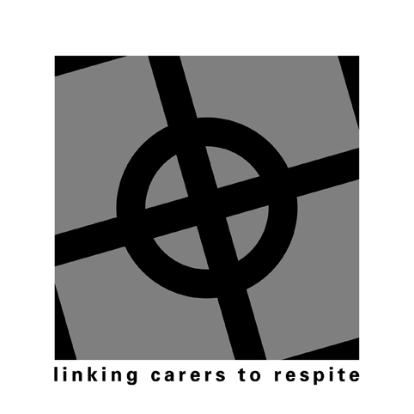 Illawarra Carer Respite Centre Emergency Care Plan 

Contacts
Primary Carer: Person requiring care:
Name Name
Address Address

Phone Age Phone Date of Birth
Relationship to carer
Language spoken at home: Language spoken at home:
Is an interpreter required:
Aboriginal/ Torres Strait Islander: Aboriginal/Torres Strait Islander:
Emergency Contacts:
Name Phone
Relationship/Organisation
Name Phone
Relationship/Organisation:
Name Phone
Relationship/Organisation:
Health Information:
General Practitioner Phone:
Address
Medicare number: Ambulance number. Medic-Alert Number
Medical/Hospital Insurance Fund Membership number Address
Describe the disability and general state of health of the person requiring care
Select the level of care required:
❐ 1 Meals only  2 Regular visits only  3 Fulltime care – mobile, no personal care required
- 4 Fulltime care – mobile, supervision of toileting and showering required
❐ 5 Fulltime care – mobile, assistance with toileting, showering/bathing required
- 6 Fulltime care assistance with lifting/transferring, toileting and showering required
- 7 Other, specify
Medication:
Where is medication kept Dosette  Blister pack  Pharmacy bottles 
Pharmacist: Address Phone
Where is prescription for medication kept
Allergies (especially to medication)
Care required:
Supervision:
Toileting: When Equipment used:
Equipment used for Showering/Bathing: Number of people required: Other:
Lifting/Transferring: When Equipment used: Number of people required:
Meals/Diet
Other
Regular Care Services Used inhome and Away from Home:
Name of Service | Type of Service | Times Provided | Days Provided | Contact Name | Contact Number

Emergency Plan

Have any specific alternative care arrangements been made? If so, what are they?

Have financial arrangements been made for an emergency? If so, what are they?

Signed:…………………………………………………………………… Relationship to person requiring care:……………………………….. ..Date:………………………………

