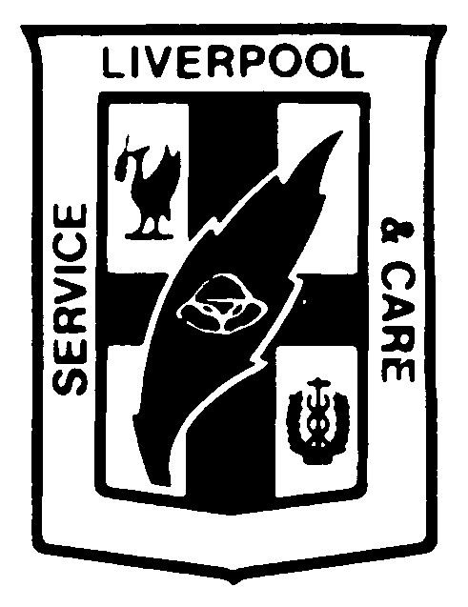
Liverpool Health Service
Staff Orientation Checklist

Name: ________________________________________

Department: ________________________________________
- The following checklist must be signed off by the employee and supervisor (or delegate) who is conducting the session to confirm that the new employee has been given the appropriate information/training.
- Additional space has been provided for specific information relevant to the ward/
department.
- The following listed information is mandatory for ALL employees.
- ALL staff are required to attend the General Orientation Program.
- The completed checklist should be retained within the ward/department.
Activity / Task | Time Frame | Date Completed | Signed off -employee | Signed off - Supervisor
Day 1 - General Orientation:  - Cultural Awareness  - Interpreter Service  - Staff Counselling  - Confidentiality  - Security  - Intro to Minimisation & Management of Aggression  - Intro to Quality & EquIP  - Overview Corporate Policies  - Basic CPR Video | Within first  2 weeks
Day 2 General Orientation:  - Fire & Safety  - Disaster / Critical Incident Management  - Medical Emergency Team  - Overview of OH&S  - Overview of Infection Control  - Manual Handling Phase 1  - Overview of Waste Management | Within first  2 weeks
Ward/Department Orientation Commenced | Day 1 - 2
Corporate Manual/ Dept Manuals/ Policies & Procedures | Within first 2 weeks
Privacy/Confidentiality | Within 1st week
Electronic & Metal Keys Arranged | Within 1st week
Access to Network PC arranged | Within 1st week
Evacuation Routes | Within 1st week
Location of fire extinguishers | Within 1st week
Procedure for Reporting Hazards | Within 1st week
Procedure for reporting Incidents/ Accidents | Within 1st week
Role of Divisional and Sector OH&S Committees | Within 2 weeks
Introduction to Performance Management | Within 2 months
PASS / Hospas training | Within 2 weeks
Smoke free Workplace - exempted smoking areas | Within 1st week
Personal Protective Equipment (PPE) | Within 1st week
Housekeeping | Within 1st week
Waste Segregation | Within 1st week
MSDS | Within 1st week
Safe Work Practices | Within 1st week
Manual Handling Equipment Training | Within 2 weeks
Multicultural skills training | Within 12 months
Minimisation & Management of Aggression Level 2 Training | Within 6 months if applicable
Aboriginal Cultural Awareness Training | Within 12 months
Essential Child Protection Procedures | Within 6 months
Service Managers must:
Attend Workforce training | Within 2 weeks
Attend ProAct/Kronos Training | Within 2 weeks
Attend Oracle training | Within 2 weeks
Other Ward/ Department Issues
CRC Organisational Manual
Carer Contacts brochure
Photo ID + Payroll Number
Motor Vehicle Fleet Management Policy
Security Licence check
Hours worked confirmation – Admin
Code for toilets
Code for photocopier
Where is the fire hydrant
Where is the Fire Exit
Enact training

